

**CIS 11051 – PRACTICAL FOR DATABASE DESIGN**

Information and communication Technology

Faculty of Technology

South Eastern University of Sri Lanka

Registration Number: SEU/IS/22/ICT/075

Academic year: 22/23

Lab Sheet 05 Part II

**Exercise 01**

1. Open mysql shell 🡪 enter password 🡪 type “create database VaccinatedStudent”

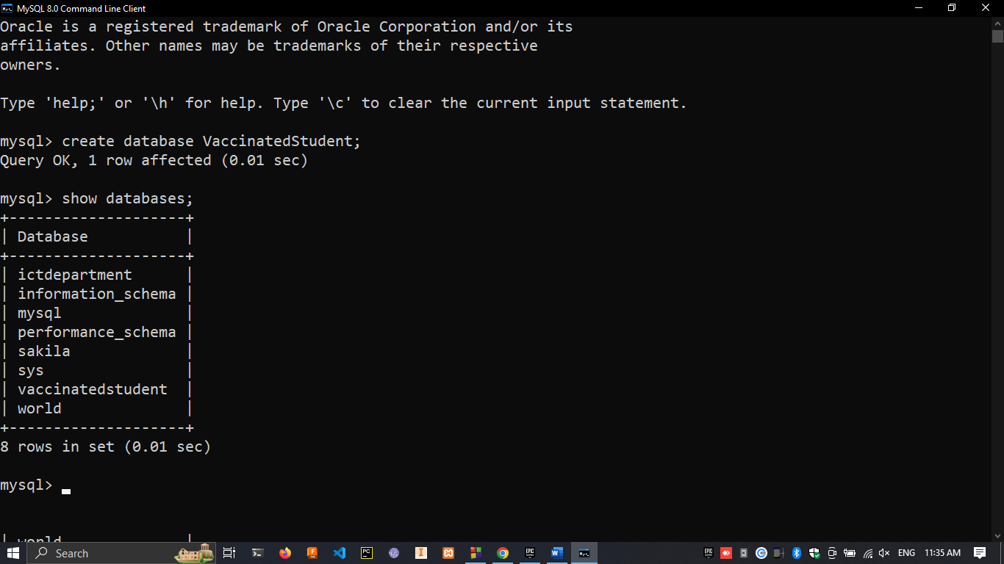

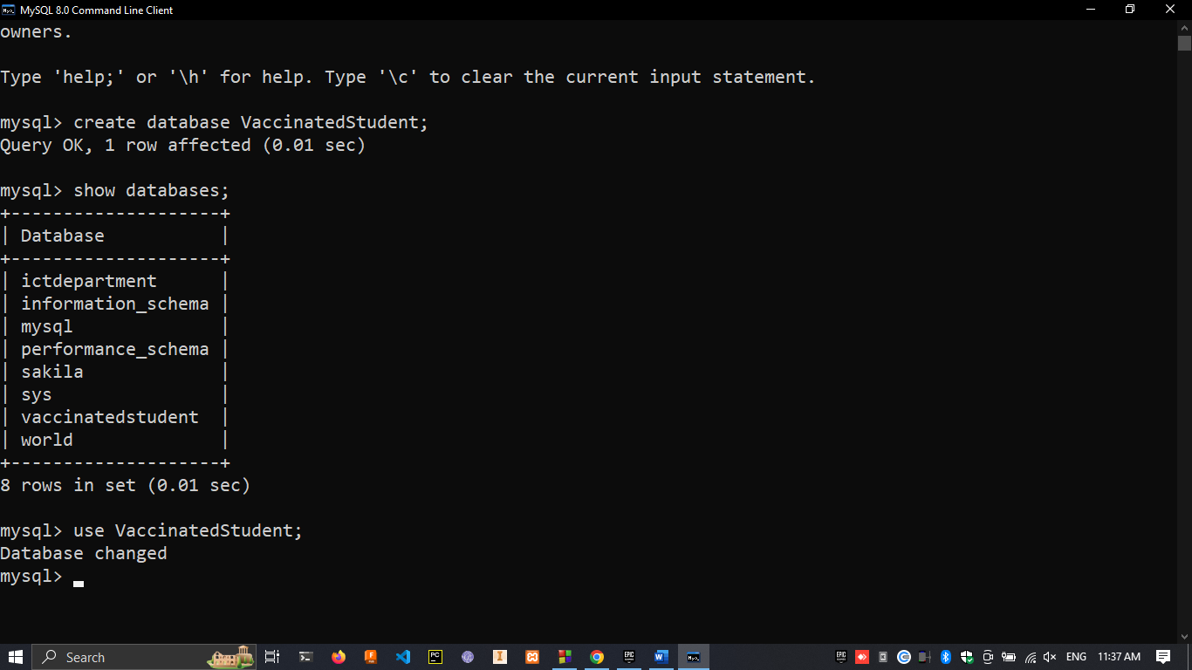

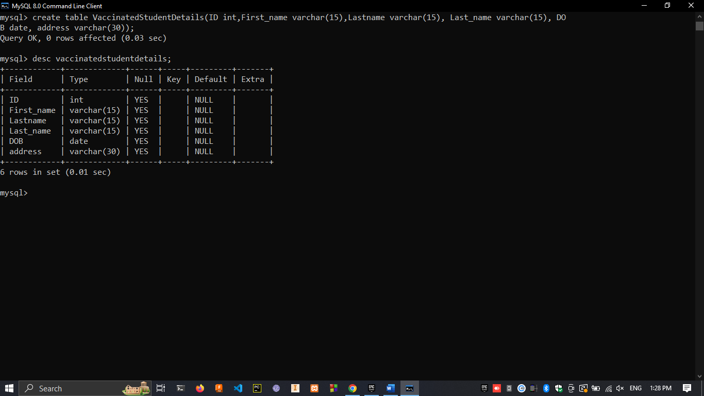



1. 